Are you Interested in Participating in a Research Study on Physical Activity Behaviors?

Study Purpose: This research study is being conducted to learn more physical activity habits.

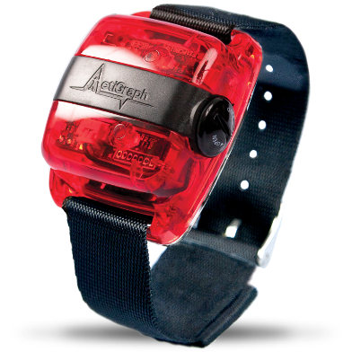
What procedures will be done in the study?:
- Questionnaires
- Wearing an activity monitor for 7-days
- Recording and assessing physical activity
- Blood draw, sample collection, and assessment of lab values

We are looking males and females:
- Ages 18-70
- Access to the internet to complete questionnaires
- Not currently participating in lifestyle interventional study

Visits will take place remotely or at the University of Colorado Anschutz Medical Campus. Visits will last less than an hour.

This study is being funded by the Division of Renal Disease and Hypertension at the University of
Colorado Anschutz Medical Campus.
For more information, please contact the study coordinator at cortney.steele@cuanschutz.edu (303) 724-0673
For more information, please e-mail
cvstudy@colorado.edu or call (303) 492-2485

For more information, please e-mail
cvstudy@colorado.edu or call (303) 492-2485

